**Space of Convergence**

**of Land and Water Struggles**

**We, social and grassroots movements and their allies** met at the African Social Forum in Dakar in October 2014, with the objective to unite all the struggles for the Land and Water and against the criminalization of activists thereof. We have developed a declaration entitled **"Rights to Water and Land, A Common Struggle"**.

This Declaration was written in a spirit of solidarity and collective pooling and aims at being a starting point for the development of a Global Convergence of Land and Water Struggle. The organizations promoting this Declaration invite you to join our space of convergence during the World Social Forum in Tunis.

We will have **joint sessions** in the mornings of March 25th, the 26th and the 27th and an assembly of convergence on March 28thto share experiences of water and land struggles at national and international level, and to build together the future of the Global Convergence.

Moreover, we have a **series of other workshops** in the course of these days which also deal with **water and land struggles** and want to associate with our space of convergence.

**The *Global Convergence of Water and Land Struggles* is a collective effort also built in close collaboration with *the Global Convergence of Resistances to Corporate Power.***

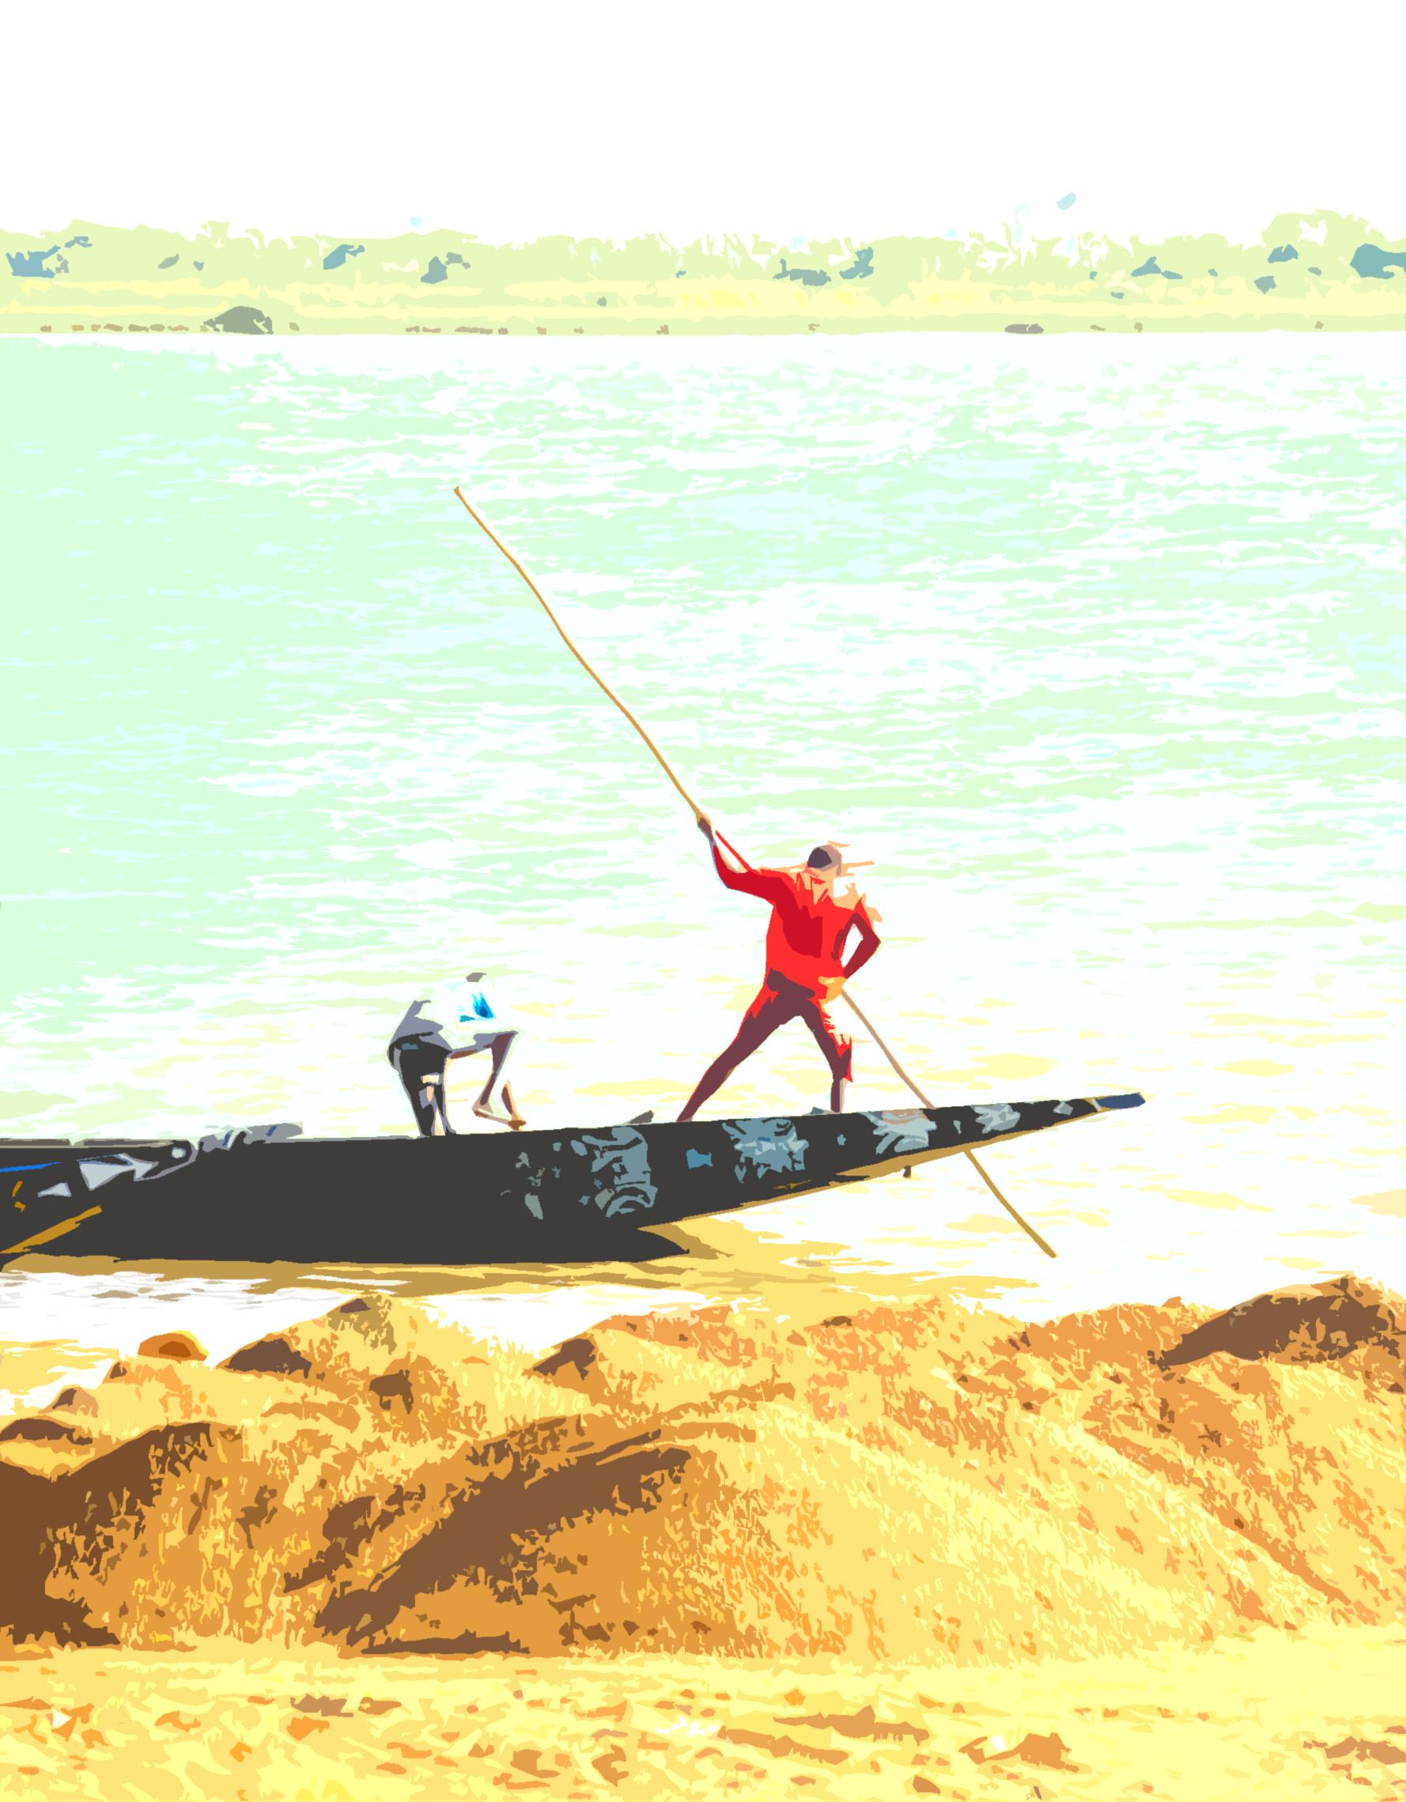

**CONVENERS: La Via Campesina, World Forum of Fisher Peoples, Convergence Malienne contre l’Accaparement des Terres, GRAIN, COSPE, Comitato Italiano Contratto Mondiale sull'acqua, Transnational Institute, Habitat International Coalition,** Terra Nuova, Friends of the Earth International, **FIAN International**

To become a co-convenor and participate in the political shaping of this Global Convergence, please write: Chantal Jacovetti, **chantal.jacovetti@wanadoo.fr**

**Mini AMPHI M** **March 25th 15h-17h30**  
**Civil society´s expectations and needs from the Habitat III process**  
**Habitat International Coalition**  
**AR** UN Habitat III توقعات المجتمع المدني والاحتياجات من عملية الموئل الثالث للامم المتحدة  
**FR** Les attentes de la société civiles et les besoins dans le processus de l'ONU Habitat III  
**EN** Civil society´s expectations and needs from the UN Habitat III process  
**ES** Expectativas de la Sociedad Civil y necesidades del proceso de la ONU Hábitat III

**AMPHI AP2 AP2 March 26th 15h-17h30  
Water as Human Right: towards an International Treaty** **Comitato Italiano Contratto Mondiale   
sull'acqua (CICMA)**  
**AR** الماء كحق من حقوق الإنسان: نحو المعاهدة الدولية  
**FR** L'eau comme un droit humain: Vers un traité international  
**EN** Water as a Human Right: Towards and International Treaty  
**ES** El agua como derecho humano: Hacia un Tratado Internacional

**I 111** **March 25th 11h30-14h**  
**The fight for Food Sovereignty: The role of La Via Campesina in the defense of peasant’s rights**  
**La Via Campesina**   
**AR** الكفاح من أجل السيادة الغذائية: دور فيا كمبسينا في الدفاع عن حقوق الفلاحين  
**FR** La lutte pour la souveraineté alimentaire: Le rôle de la Via Campesina dans la défense des droits des paysans/nes  
**EN** The fight for Food Sovereignty: The role of La Via Campesina in the defense of peasant’s rights  
**ES** La lucha por la Soberanía Alimentaria: El papel de la Vía Campesina en la defensa de los derechos de los y las campesinas

**Salle SE1 March 26th 8h30-11h**

**Land grabbing: strategies of resistance against multinationals: the case of Olam in Gabon, Dekeloil in Cote d'Ivoire and Bolloré in 5 countries in Africa and Asia**  
*Co-Organizers :***GRAIN, Attac Gabon**  
**AR**الإستيلاء على الأراضي: إستراتيجيات المقوامة ضد الشركات متعددة الجنسيات: وضعية أولام في الغابون و ديكيلوال في ساحل العاج و باللوري في 5 بلدان في القارتين الإفريقية و الأسياوية   
**FR**Accaparement des terres : stratégies de résistance contre les multinationales : le cas de Olam au Gabon, Dekeloil en Côte d'Ivoire et Bolloré dans 5 pays d'Afrique et d'Asie  
**EN**Land grabbing: strategies of resistance against multinationals: the case of Olam in Gabon, Dekeloil in Cote d'Ivoire and Bolloré in 5 countries in Africa and Asia  
**ES**Acaparamiento de las tierras: estrategias de resistencia contra las multinacionales: el caso de Olam en Gabón, Dekeloil en Costa de Marfil y Bolloré en 5 países de África y de Asia

**Salle SE 1 March 26th 15h-17h30  
Opposing the Corporate “New Alliance for Food Security” in Africa  
ActionAid, Brot für die Welt - Evangelischer Entwicklungsdienst, Terra Nuova, CCFD-Terre Solidaire**  
**AR** معارضة شركات "التحالف الجديد للأمن الغذائي" في أفريقيا  
**FR** S'opposer à la Corporation "Nouvelle alliance pour la sécurité alimentaire" en Afrique  
**EN** Opposing the Corporate “New Alliance for Food Security” in Africa  
**ES** Oponiéndose al aspecto corporativo de la "Nueva Alianza para la Seguridad Alimentaria" en África

**Salle SP17 March 26th 11h30-14h**

**STOP WATER GRABBING, join the global advocacy campaign**   
**COSPE**  
**AR** أوقفوا الاستيلاء على الماء، إنضموا إلى حملة المرافعة العالمية  
**FR**Stop à l'Accaparement de l'Eau, rejoignez la campagne de plaidoyer mondiale !  
**EN**Stop Water Grabbing, join the global advocacy campaign!  
**ES** Detener el acaparamiento de agua, unirse a la campaña mundial de movilización

**Salle TD 4 March 26th 8h30-11h**

**Middle East/North Africa Land Forum**  
**Housing and Land Rights Network (HLRN)**  
**AR**منتدى الأرض للشرق الأوسط وشمال إفريقيا   
**FR**Le Forum De la Terre en Afrique du Nord et au Moyen Orient  
**EN**Middle East/North Africa Land Forum  
**ES**Foro de la Tierra de Oriente Medio y el Norte de África

**Salle SP15** **March 26th 8h30-11h**

**Agroecology – the future farming; experiences and concepts**

**More and Better Network**

**AR** الزراعة الإيكولوجية - زراعة المستقبل؛ تجارب ومفاهيم

**FR**  Agroécologie - l'agriculture de l'avenir; expériences et concepts

**EN** Agroecology – the future farming; experiences and concepts

**ES** Agroecología - agricultura del futuro; experiencias y conceptos

**AMPHI AC1 AC1 March 26th 15h-17h30**

**The current water question in the Iraqui and Syrian crisis**  
*Co-Organizers :*[**Iraqi Civil Society Solidarity Initiative**](http://registration.fsm2015.org/view_orga/6274)**, Un ponte per..., المنتدى الاجتماعي العراقي, Kurdish Network**   
**AR**ازمة المياه في العراق وعلاقتها بالنزاع المسلح في سوريا  
**FR**La question actuelle de l'eau dans le conflit en Irak et en Syrie  
**EN**The current water question in the Iraqi and Syrian crisis  
**ES**La cuestión actual del agua en el conflicto de Irak y Siria

**WORKSHOPS:**

**Mini AMPHI G** **March 25th 15h-17h30**  
**Migration and Land grabbing: how peasants suffer and what alternatives?**  
**La Via Campesina**  
**AR** الهجرة والاستيلاء على الأراضي: معاناة المزارعين و ما هي البدائل؟  
**FR** Migration et accaparement des terres: comment souffrent les paysans et quelles sont les alternatives?  
**EN** Migration and Land grabbing: how peasants suffer and what alternatives?  
**ES** Migración y el acaparamiento de tierras: ¿cómo los agricultores están sufriendo y cuáles son las alternativas?

**AMPHI B B March 25th 8h30-11h**

**Global Convergence of Land and Water struggles (1)**

*Organizer:*   
**Conveners of the Convergence of Land and Water Struggles**  
**AR**ا التقاربات العالمية في النضال ضد الاستحواذ على الاراضي والماء (1)  
**FR**Convergence globale des luttes de terres et des eaux  
**EN**Global Convergence of Lands and Waters struggles  
**ES**Convergencia Mundial de las Luchas contra los Acaparamientos de Tierras y Agua

**AMPHI B B March 27th 8h30-11h**

**Global Convergence of Land and Water struggles (3)**  
*Organizer:*  
**Conveners of the Convergence of Land and Water Struggles**  
**AR**التقارب العالمي من النضال من أجل الأرض والمياه (3)  
**FR**Convergence mondiale des luttes contre l'accapparement des terres et de l'eau (3)  
**EN**Global Convergence of Lands and Waters struggles (3)  
**ES**Convergencia Mundial de las Luchas contra los Acaparamientos de Tierras y Agua (3)

**March 28th 11h30-13h30**

**Assembly of Global Convergence of Land and Water Struggles**

*Organizer:*   
**Conveners of the Convergence of Land and Water Struggles**  
**AR**النضالات العالمية لنضالات الأرض و الماء  
**FR**Assemblée de la Convergence globale des luttes de terres et des eaux  
**EN**Assembly of Global Convergence of Land and Water struggles  
**ES**Asamblea de la Convergencia Mundial de las Luchas contra los Acaparamientos de Tierras y Agua

**AMPHI B B March 26th 8h30-11h**

**Global Convergence of Land and Water struggles (2)**  
*Organizer:*  
**Conveners of the Convergence of Land and Water Struggles**  
**AR** التقاربات العالمية في النضال ضد الاستحواذ على الاراضي والماء (2)  
**FR**Convergence mondiale des luttes contre l'accapparement des terres et de l'eau (2)  
**EN**Global Convergence of Lands and Waters struggles (2)  
**ES**Convergencia Mundial de las Luchas contra los Acaparamientos de Tierras y Agua (2)

**JOINT SESSIONS:**

**amphi B B March 26th 8h30-11h Global Convergence of Land and Water struggles (2)**  
*Co-Organizer :*   
**GRAIN, La Via Campesina, CMAT, COSPE, onlus, Comitato Italiano Contratto Mondiale sull'acqua- (CICMA), Transnational Institute, FIAN International**  
**AR**التقاربات العالمية في النضال ضد الاستحواذ على الاراضي والماء (2)  
**FR**Convergence mondiale des luttes contre l'accapparement des terres et de l'eau (2)  
**EN**Global Convergence of Lands and Waters struggles (2)  
**ES**Convergencia Mundial de las Luchas contra los Acaparamientos de Tierras y Agua (2)

**amphi B B March 27th 8h30-11h**

**Global Convergence of Land and Water struggles (3)**  
*Co-Organizer :* **La Via Campesina, CMAT**

**COSPE, FIAN International, Comitato Italiano Contratto Mondiale sull'acqua- (CICMA), Transnational Institute, GRAIN**  
**AR**التقارب العالمي من النضال من أجل الأرض والمياه (3)  
**FR**Convergence globale des luttes pour l'eau et la terre (3)  
**EN**Global Convergence of Lands and Waters struggles (3)  
**ES**Convergencia global de las luchas por la tierra y el agua (3)